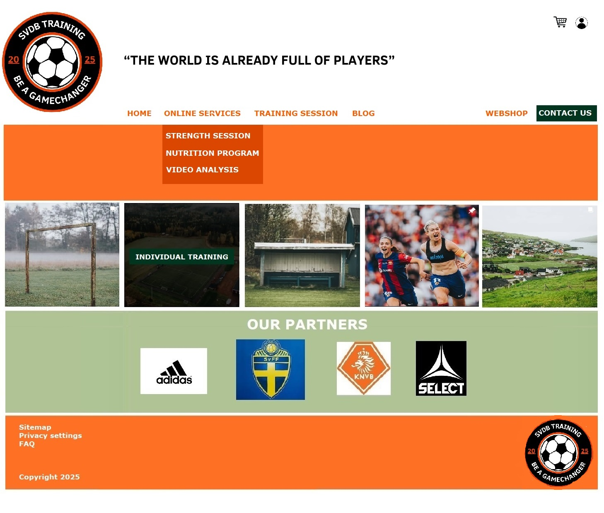

Layout with 3 working websites, Homepage, About Us and Contact us

**WEBSITE - Homepage**:

Use **Javascript** for the dropdown menu

Logo and navbar will be **responsive** for desktop and mobile with the burger icon

**Navigation Bar:**

Display: **block**

Dropdown menu using **Javascript**.

**Imagelinks**:

Above imagelinks comes an heading: Our most booked services:

When hovering over the image, the bookable training type shows

Use **Javascript** for the imagelinks

Position Imagelinks with display: **grid** template-columns; repeat(4, 1fr) [fractions clips the width in 4]

On mobile the images will show in 2 columns so its **responsive**

**Partners:**

Display partners container with display: **Flexbox**

**NO FUNCTION - All Booking websites from imagelinks or dropdown menu:**

Coming soon or show a **video** with <Iframe>

**WEBSITE - About us:**

Short summary about me with a picture slideshow or a timeline done with **Javascript**

**WEBSITE - Contact Us:**

Making a **contact form** that can be submitted and gives a message/an alert saying thanks for contacting us

Use **Javascript** for validation of the contact form

**NO FUNCTION - Webshop:**

Coming soon

**NO FUNCTION - Log in**: Future function but now with a click on the login icon I want an **alert** popping up where you can insert username and password

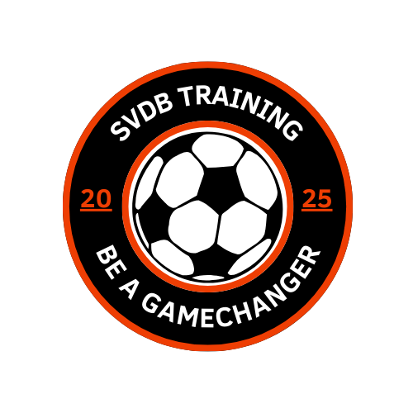

Logo for mobile

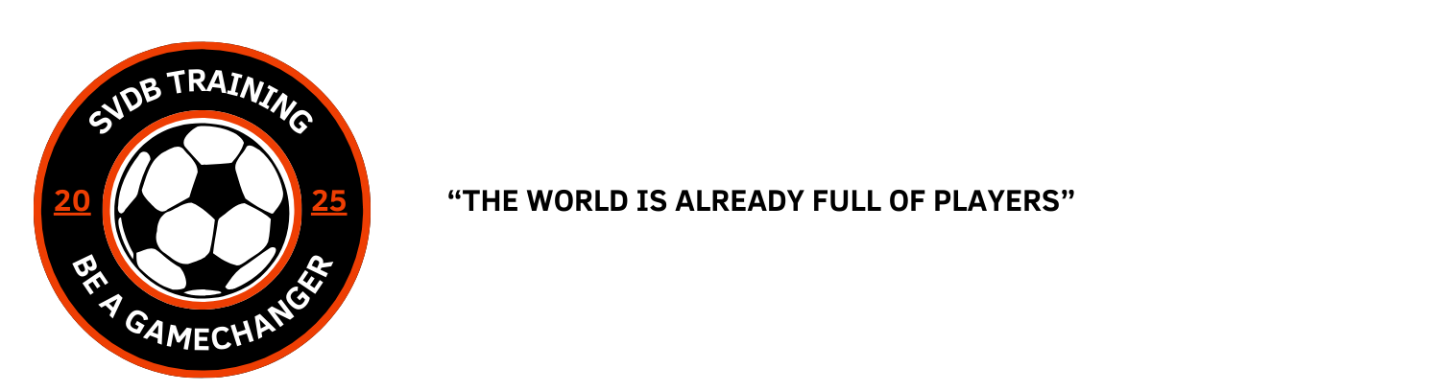

Logo for desktop

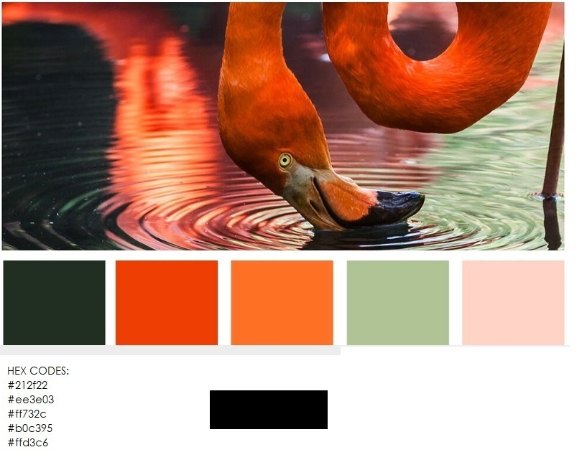

Color palette for website